NAME : PUTERA MUHAMMAD SYABIL BIN SARIANTO

KHOO JIE XUAN

PHARVEISH A/L SELVAM

LAB 7

EXERCISE 1

QUESTION 1

Lecturer class call methods in course class through pointer variable C

QUESTION 2

A) Association just indicates that there is a relationship between the classes. However, aggregation means that there is a one-way relationship between the two classes. It means “has a” relationship between classes and two of these classes are independent to each other.

B) Aggregation stated clearly that the relationship between two classes and two of these classes are independently exists. Friend class is just giving a class access to another class’s private members.

QUESTION 3

Person class is in aggregation with textbook and course class.

EXERCISE 2

QUESTION 1

1. A)

|  |  |  |
| --- | --- | --- |
| Name of the aggregation approach | Description of the approach | The line number that implement the aggregation approach |
| Aggregation | Represent an ownership relationship between two classes | 5,40 |
| Composition | Represent an exclusive ownership relationship between two classes | 21,41 |

B)

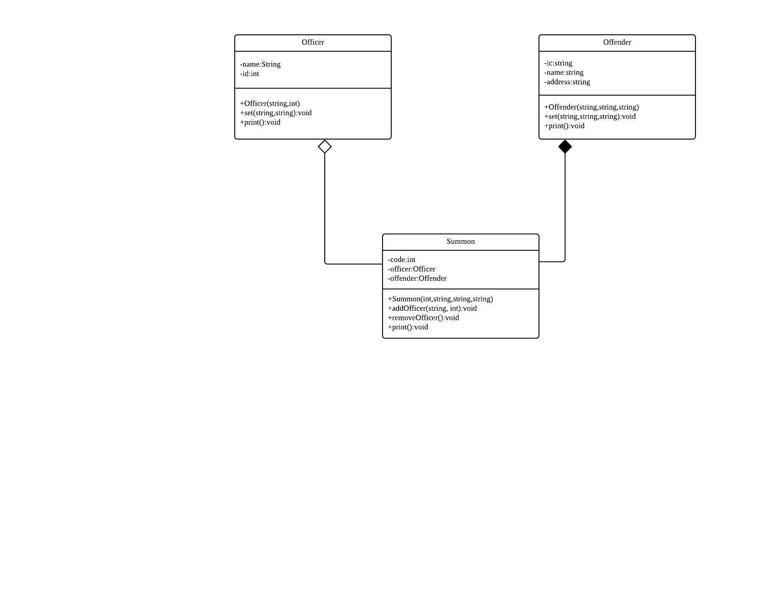

C)

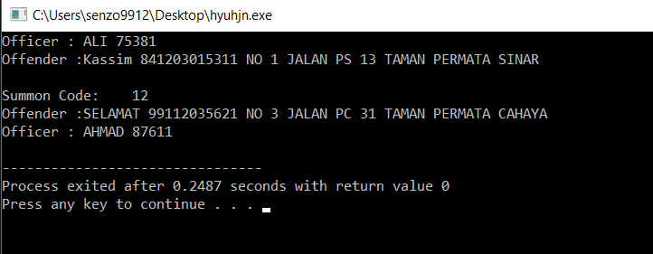

QUESTION 2

2.

A) 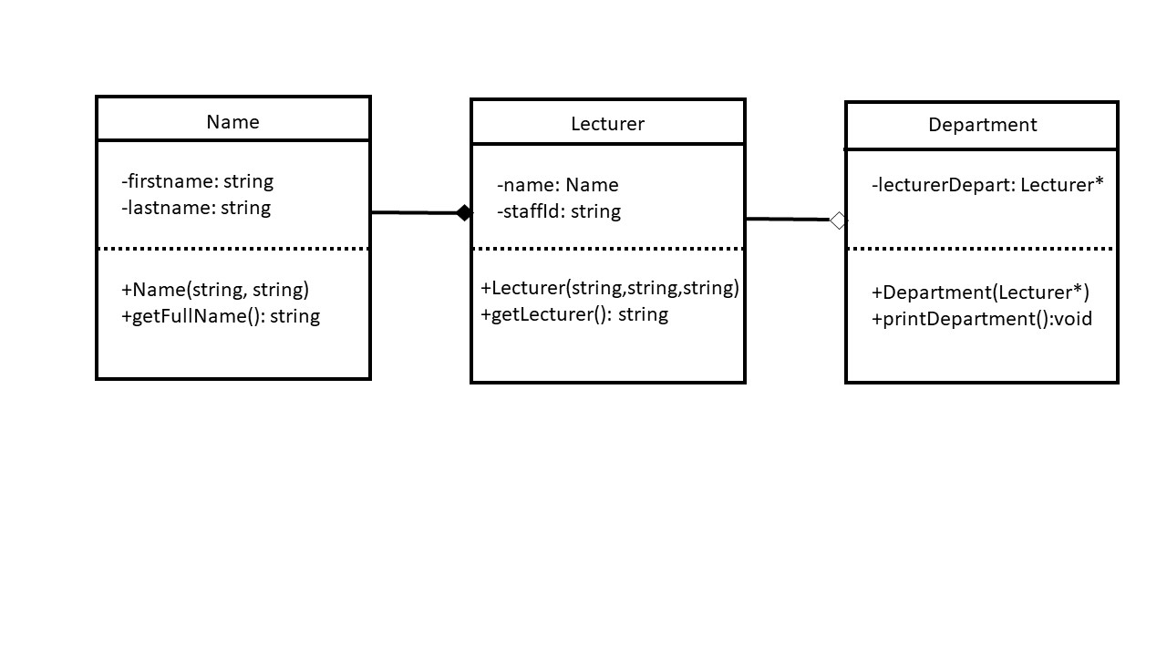

B)

Lecturer name: AbdullahHamid

Lecturer id: 124

C)

#include<string>

#include<iostream>

using namespace std;

class Student

{ private:

string studName;

int stdId;

public:

};

class Professor

{

private:

int numOfTeaching;

string profName;

public:

Profesor(string p)

{

profName=p;

}

string display()

{

return profName;

};

~Professor();

};

class College

{

private:

string name;

Student stud;

Professor *prof;

public:

College(string n,Professor* p)

{

n=name;

p=prof;

}

~College();

};

QUESTION 3

3. a)

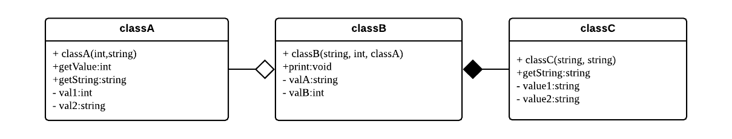

b)



QUESTION 4

A)

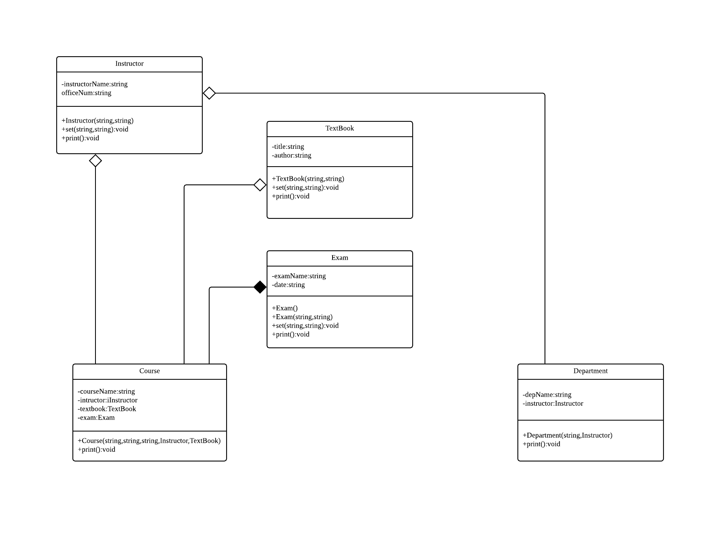

B)

